Creative Course / Workshop Proposal Form
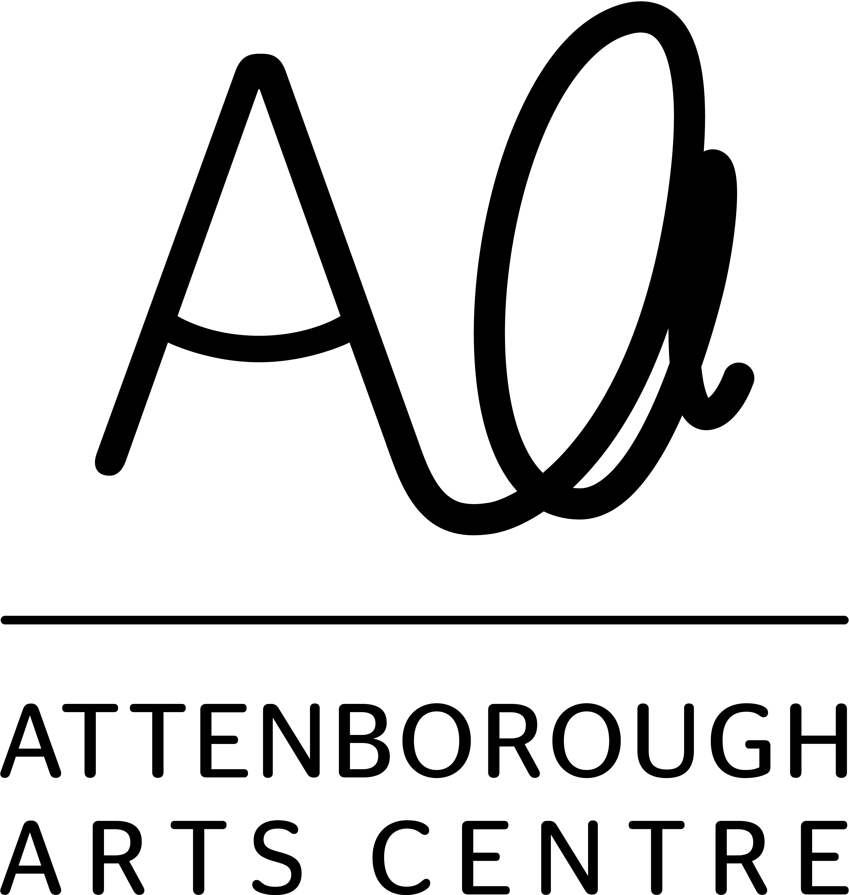
Summer Term, April - July 2025

Please complete and return by 12noon on Wednesday 8 January 2025 to Kate Foster at kf123@le.ac.uk

Sorry, late or incomplete proposals will not be accepted.

If you are proposing more than one course/workshop, please complete a separate form for each one.

Name:
Company name:
Address:
Postcode:
Email:
Mobile:
Website:
Facebook:
Instagram:

Title of course/workshop

Duration of course/workshop  Ideally should be either:  10 weeks (1.5-3 hours per session)  5 weeks (1.5-3 hours per session)  1 day (3-6 hours one-off workshop) | eg 10 week course, 2 hours per week

Discipline eg Ceramics, painting, dance etc

Days/times of the week you could deliver
Please list all options and be as flexible as possible, eg:
Any weekday evening between 5-9pm
Any Saturday except 8 June
Available 7 days a week between 9am-2pm
Please note: we will not be scheduling Weds evenings or Sundays this term.

Course / workshop summary (max 200 words)
(as you would write to promote it to participants – short, punchy, informative – including what level of experience is required)

Detailed description of the course content and about you/brief tutor biog
(including objectives, teaching and learning techniques, materials and tools to be used, learning outcomes, maybe week by week list of what sessions would include etc and one brief paragraph about you, the tutor – experiences, passions, work history etc)

Target audience – who will this course/workshop appeal to/be most suitable for?

What specialist equipment and materials would you need to deliver the course/workshop – please list EVERYTHING you would need us to provide for the entire duration and/or if there is any equipment you might provide yourself (usually only necessary if very specialist)  Estimated cost of materials per person  This is approximate only, just helpful to have a rough idea when assessing feasibility. | £

If you deliver this course/workshop at any other venues, please give details here, including the dates, participant numbers and advertised prices…

References (for new tutors only)
If you have not previously taught at AAC, please provide the name, position, mobile and email address of two professional contacts who could provide a reference for you. They should be able to feedback on things like the quality of your tutoring and the satisfaction of previous workshop participants.
1
2

Would you require any adjustments to support you to tutor at Attenborough Arts Centre?

Please attach at least 2 beautiful/impactful/inspiring images that represent what participants might produce and would be suitable to use in marketing your workshop/course if selected. Plus an image of yourself in your workshop or teaching scenario or similar for use on social media. Tick here to confirm you have attached these with your submission and we have permission to use the images in our online and print materials.

Please mark with an X if you would like to remain on the creative learning mailing list for future call outs

Thank you for taking the time to submit a proposal for the new Summer 2025 Creative Learning programme. We will be in touch later in January 2025 to discuss next steps if accepted for this term’s programme.

Proposals must be submitted to Kate at kf123@le.ac.uk no later than 12noon on Wednesday 8 January 2025.

Thank you!

